|  |
| --- |
| IFMR RURAL FINANCE |
| Loan Booking Process |
|  |
| **Krithika Manokaran| IFMR Rural Finance** |
| **8/10/2016** |

Contents

1. Process Diagram 5

2. Stage definition 6

3. Stage-role access 7

4. Pre requisite for loan booking process 8

4.1 UI specification 8

4.2 Screenshot 11

4.3 Functional Requirements 11

4.4 Uploads 11

4.5 Downloads 12

4.6 Reports 12

5. Pending for loan Booking 13

5.1 UI Requirements 13

5.2 Screenshots 13

5.3 Functional Requirements 14

5.4 Uploads 15

5.5 Downloads 15

5.6 Reports 15

6. Document Execution 16

6.1 UI Requirements 16

6.1.1 Document Generation artifacts 16

6.1.2 Document Upload artifacts 16

6.2 Screenshots 17

6.3 Functional Requirements 18

6.4 Upload 19

6.5 Download 19

6.6 Reports 19

7. Pending for Document Verification 20

7.1 UI requirements 20

7.1.1 UI view- checker for document verification 20

7.2 Screenshots 21

7.3 Functional requirements 21

7.4 Uploads 22

7.5 Downloads 22

7.6 Reports 22

8. Ready for Disbursement 23

8.1 UI Requirements 23

8.2 Screenshots 23

8.3 Functional requirements 24

8.4 Upload 25

8.5 Download 25

8.6 Reports 25

9. Rejected Disbursement 26

9.1 UI requirements 26

9.2 Screenshots 26

9.3 Functional requirements 27

9.4 Uploads 28

9.5 Downloads 28

9.6 Reports 28

10. Disbursement confirmation 29

10.1 UI requirements 29

10.2 Screenshots 29

10.3 Functional requirements 30

10.4 Uploads 31

10.5 Downloads 31

10.6 Reports 31

11. Multiple Tranche Process 32

11.1 UI requirements 32

11.2 Screenshots 32

11.3 Functional Requirements 33

11.4 Uploads 33

11.5 Downloads 33

11.6 Reports 34

12. Pending for FRO(Field Risk Officer) Approval 35

12.1 UI Specification 35

12.2 Screenshots 35

12.3 Functional Requirements 36

12.4 Uploads 37

12.5 Downloads 37

12.6 Reports 37

13. Pending for CRO (Central Risk Officer) Approval 38

13.1 UI Requirements 38

13.2 Screenshots 39

13.3 Functional requirements 39

13.4 Uploads 40

13.5 Downloads 40

13.6 Reports 40

14. EMI Schedule Generation 41

14.1 UI Requirements 41

14.2 Screenshots 42

14.3 Functional Requirements 42

14.4 Uploads 43

14.5 Downloads 43

14.6 Reports 43

# Process Diagram



# Stage definition

|  |  |
| --- | --- |
| **Stage** | **Description** |
| Loan Booking | Loan Booking stage will be the starting stage for Loan processing in PERDIX for Phase I. Pre-stage activity will be to upload the Loan and Customer details that are captured in Artoo System. In this stage, those Loans that are yet to be processed for Disbursement are listed. User will capture the "Expected Disbursement Date" and "Customer Sign Date" at this stage. |
| Document Generation & Upload | List of Loans which are updated in the previous stage, "Loan Booking" are listed here. User can generate the documents for the Loan, get the signature from the customer and upload the same for a loan. |
| Document Verification | This stage will list all the loans for which Documents are uploaded for verification. User will have provision to approve/reject the documents attached to the loan. If a single document is rejected, the task will go back to "Document Generation & Upload" for correction on the rejected document. If all the attached documents are approved, then the task will move on to next stage, "Ready for Disbursement" |
| Ready for Disbursement | This stage will list all the loans for which the documents are verified and approved. The user will have a provision to download a list of such loans into an Excel, update the bank details and upload it back in the system. On upload, the tasks will move on to "Disbursement Confirmation Stage". User can choose to reject a Loan from the list and the rejected Loans will get into "Rejected Disbursement Queue". |
| Disbursement Confirmation | This stage will list all the loans which are marked as "Sent for Disbursement". Once, the user receives confirmation excel from bank, it will be uploaded and successful disbursements are marked paid and move out of this stage. If the disbursement has failed, then the task will go to "Rejected Disbursement Queue". |
| Rejected Disbursement Queue | This stage will list all the loans that are rejected due to disbursement failure. User to correct the Account details and save. On save, the task will move into "Pending for Disbursement" Stage. |

# Stage-role access

|  |  |
| --- | --- |
| **Stage** | **Applicable Role** |
| Loan Booking | Hub Manager |
| Document Generation & Upload | Hub Manager |
| Document Verification | MIS Team |
| Ready for Disbursement | Finance Team |
| Disbursement Confirmation | Finance Team |
| Rejected Disbursement Queue | Hub Manager |

# Pre requisite for loan booking process

## UI specification

|  |  |  |  |  |  |
| --- | --- | --- | --- | --- | --- |
| **Field name** | **Section** | **Data Type** | **Attribute** | **Validations/Restrictions** | **Population logic** |
| Partner name | Product details | Text | Write | Drop down – Master | Drop down – Master |
| Loan type | Product details | Text | Write | Drop down – Master | Drop down – Master |
| Frequency | Product details | Text | Write | Drop down – Master | Drop down – Master |
| Customer Name | Customer details | Text | Read | Search option | By Name/URN/Mobile number |
| Customer URN | Customer details | Numeric | Read | Auto | From customer table |
| Loan/Repayment Tenure | Loan Details | Numeric | Write |  | As per product configuration parameters |
| Loan Amount | Account Details | Numeric | Write |  | As per product configuration parameters |
| Loan Application date | Account Details | Date | Auto | Date cannot be future | Today date |
| Customer Insurance selection | Enrollment details | Text | Write | Entity is created, Applicants and co applicants are linked to entity, selection needs to be done during  enrollment | Based on enrollment data |
| Nominee details | Insurance details | Text | Write | Drop down | Family table |
| Guardian Details | Insurance details | Text | Write | Drop down – Only for minor nominee | Family table |
| Loan purpose Level 1 | Account Details | Text | Drop down | Master table | Master table |
| Loan purpose Level 2 | Account Details | Text | Drop down | Master table | Master table |
| Loan purpose Level 3 | Account Details | Text | Drop down | Master table | Master table |
| Centre Name | Account Details | Text | Drop down | Master table | Master table |
| Guarantor URN | Guarantor Details | Numeric | Search from customer table | Customer table | Customer table |
| Guarantor DSC Override | Guarantor Details | String |  | Customer table | Customer table |
| Guarantor DSC Remarks | Guarantor Details | String |  | Customer table | Customer table |
| Guarantor Liabilities | Guarantor Details | Numeric | Search from customer table | Liabilities table | Liabilities table |
| First name | Guarantor Details | Numeric | Search from customer table | Customer table | Customer table |
| Middle name | Guarantor Details | Numeric | Search from customer table | Customer table | Customer table |
| Date of Birth | Guarantor Details | Numeric | Search from customer table | Customer table | Customer table |
| Address | Guarantor Details | Numeric | Search from customer table | Customer table | Customer table |
| Assets | Guarantor Details | Numeric | Search from customer table | Customer table | Customer table |
| Liabilities | Guarantor Details | Numeric | Search from customer table | Customer table | Customer table |
| Collateral Type | Collateral Details | Text | Drop down | Master table | Master table |
| Collateral Description | Collateral Details | Text | Write | Upto 200 characters |  |
| Collateral Value | Collateral Details | Numeric | Write | Upto 15 digits |  |
| Document 1 | Collateral Details | Pdf/jpg | Upload | Less than 1 MB | Based on Product configuration masters |
| Document 2 | Collateral Details | Pdf/jpg | Upload | Less than 1 MB | Based on Product configuration masters |
| Document 3 | Collateral Details | Pdf/jpg | Upload | Less than 1 MB | Based on Product configuration masters |
| Photo | Collateral Details | Pdf/jpg | Upload | Less than 1 MB | Based on Product configuration masters |
| Interest Rate | Sanction details | Numeric -Decimals | Write | Upto 3 digits. check with Product configuration Interest rate range. |  |
| Processing Fees | Sanction details | Numeric -Decimals | Write | Upto 3 digits. check with Product configuration Processing fee range. |  |
| CIBIL Charges | Sanction details | Numeric –Decimals | Write | Upto 4 digits. |  |
| Repayment mode | Sanction details | Text | Write | Drop down - master | Master table – 2 fields- ACH/PDC |
| Sanction amount | Sanction details | Numeric | Write | Upto 15 digits |  |
| Sanction date | Sanction details | Date |  | Not previous date | >=Today date |
| Multi tranche | Sanction details | Radio | Write | Yes/No | IF yes then populate the tranche fields. |
| Tranche details | Sanction details | Text | Read |  | Sample as below:  1st tranche – 50%  2nd tranche – 30%  3rd tranche – 20%  Remarks will be mentioned at the time of sanction example – second tranche to be disbursed only after machinery is purchased. |

## Screenshot

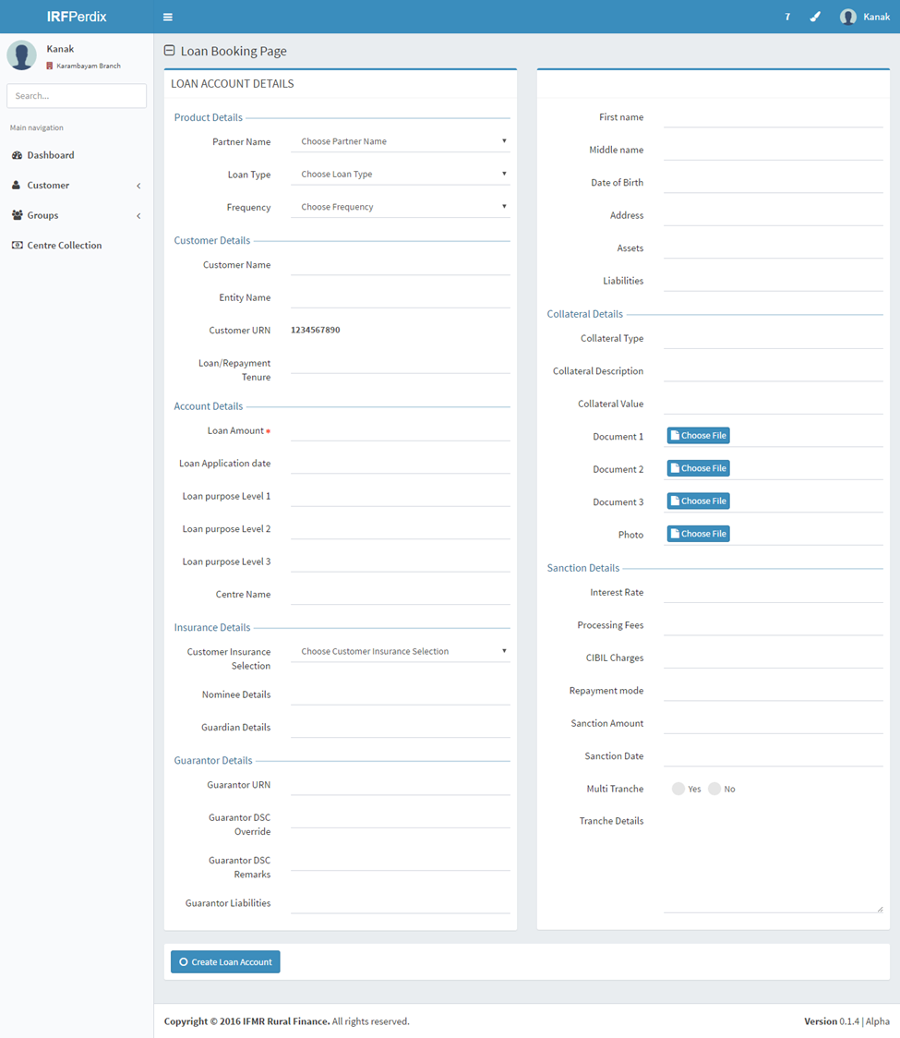

## Functional Requirements

MIS Team log in:

* 1. Manual entry of the loan details to be done.
  2. On submit, Loan will go to “Pending for Loan Booking” Stage.

## Uploads

* Excel template to upload the Loan Details.
* Excel template to upload the Entities

## Downloads

-NA-

## Reports

-NA-

# Pending for loan Booking

## UI Requirements

|  |  |  |  |  |  |
| --- | --- | --- | --- | --- | --- |
| **Field name** | **Section** | **Data Type** | **Attribute** | **Validations/Restrictions** | **Population logic** |
| Customer Sign Date | Booking details | Date | Write | a. Date >= today | Date format (DD/MM/YY) |
| Expected Disbursement Date | Booking details | Date | Read/Write | a.Date – Auto Populate (Customer sign date+ 2)  b.Provision to change to any future date – which is greater than (customer sign date+2) | Date format (DD/MM/YY) |
| Account number | Booking details | Numeric | Auto generate |  | Based on logic defined by Kinara |

## Screenshots

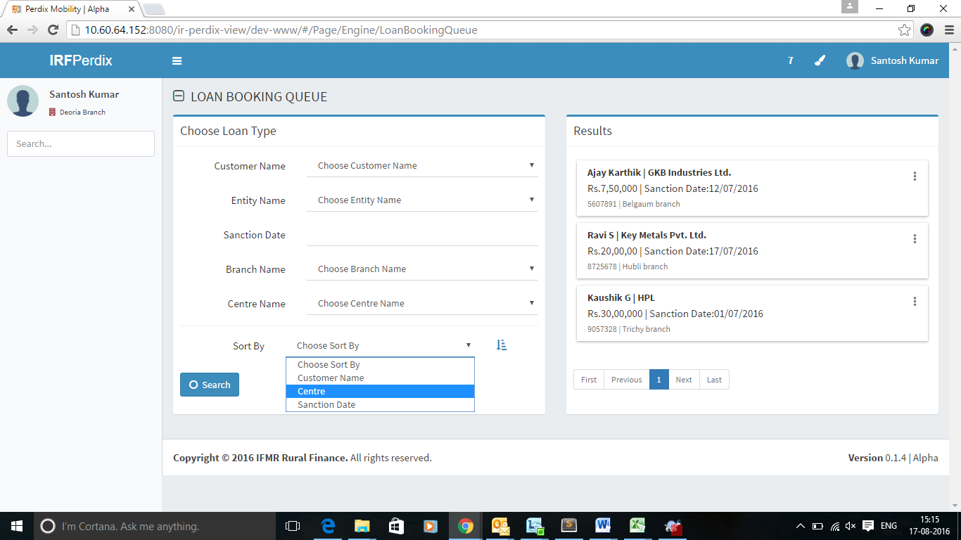

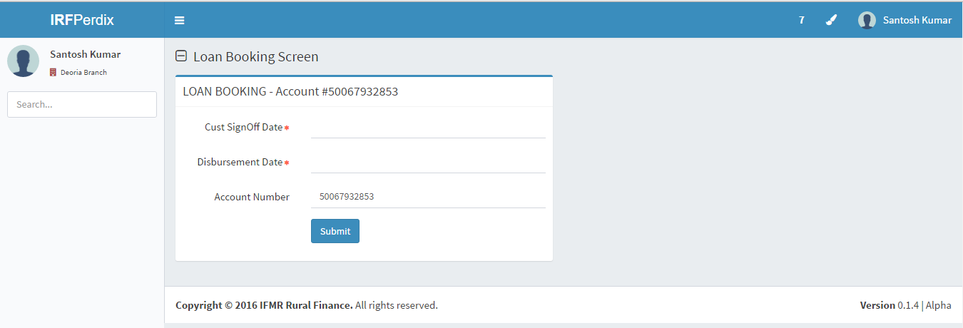

## Functional Requirements

Loan Booking Queue:

1. List all the loans pending for loan booking.
2. Conditions: All loans which have been sanctioned and not booked will be displayed in this screen. For Phase I, all loans booked via Excel upload will get listed in this queue.
3. All the loans will be displayed with basic details like
   * 1. Loan ID
     2. Entity Name
     3. Branch Name
     4. Sanction Date
     5. Loan Officer Name
     6. Spoke Name
     7. Hub Name
4. Search Option to be provided with Customer Name, Entity Name, and Branch Name.
5. Sorting can be done based on the above 7 fields.

Capture Details

1. Click on the loan account will open a new screen to capture the capture the customer sign date and expected disbursement date.
2. On save following validations required:
   1. Condition 1: If the difference between the disbursement date and sanction date is greater than 30,
      1. Then, system will not allow booking this loan. Loan cannot be disbursed after 30 days from sanction.
      2. During phase II release, the task will be routed back to again perform sanction on the Loan.
   2. Condition 2: If the difference between disbursement date and sanction date is less than 30,
      1. Then, on submit, the task will move to “Document Generation & Upload” stage.

## Uploads

-NA-

## Downloads

-NA-

## Reports

-NA-

# Document Execution

## UI Requirements

Following artifacts are required for generation and upload in this stage.

## Document Generation artifacts

|  |  |  |  |
| --- | --- | --- | --- |
| **S.No** | **Artifact name** | **Document bundled in the artifact** | **Download/Upload or both** |
| 1 | Loan Application | 1.Applicant details 2.Co applicant details 3.Guarantor details | Download and Upload |
| 3 | Legal Schedule | 1.Schedule  2.DPN 3.Authorization for deduction of fees and charges 4.Asset surrender 5.Vendor Declaration 6.Language affidavit  7. Authorization letter to disburse to third party account | Download and Upload |
| 4 | Loan sanction documents | 1.EMI schedule 2.Receipt  3.Sanction letter 4.Self declaration letter | Download and Upload |

## Document Upload artifacts

|  |  |  |
| --- | --- | --- |
| **S.No** | **Artifact name** | **Document bundled in the Artifact** |
| 1 | Loan Application | 1.Applicant details 2.Co applicant details 3.Guarantor details |
| 2 | Legal Agreements | 1.Secured document 2.Unsecured document 3.Hypothecation 4.Guarantor 5.RF 6.RFID |
| 3 | Legal Schedule | 1.Schedule  2.DPN 3.Authorization for deduction of fees and charges 4.Asset surrender 5.Vendor Declaration 6.Language affidavit  7. Authorization letter to disburse to third party account |
| 4 | Loan sanction documents | 1.EMI schedule 2.Receipt  3.Sanction letter 4.Self declaration letter |
| 5 | PDC/ACH | 1.ACH approval form -Download 2.PDC's |
| 6 | PHS | 1.Medical form |
| 7 | Supporting documents | 1.PAN card 2.Aadhar card 3.Address proof related 4.Machine photos  5.Proforma Invoice 6.Purchase order New 7.Premises photo 8.Bank account statement  These documents are uploaded into Perdix from Artoo during Phase 1. |

## Screenshots

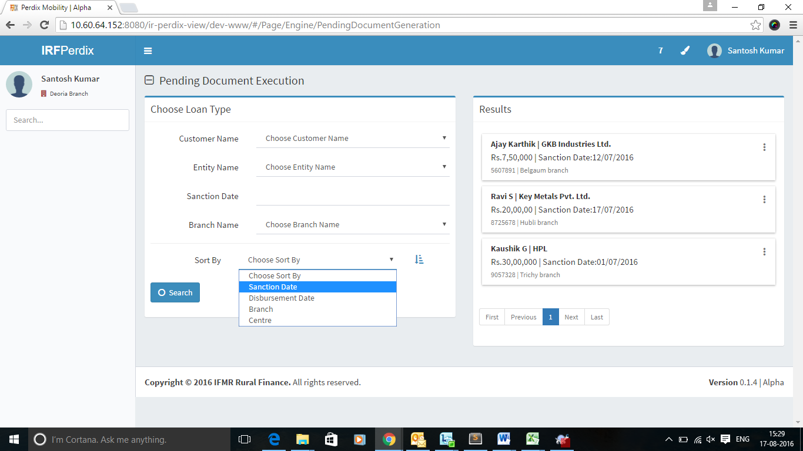

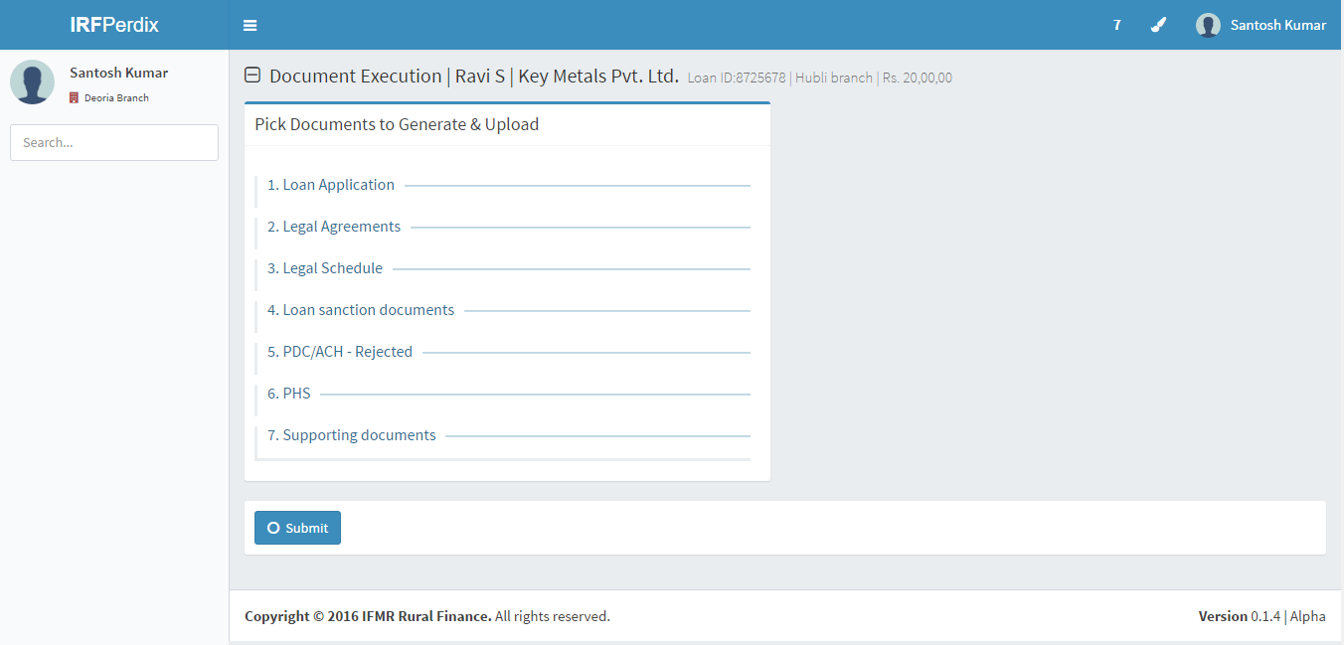

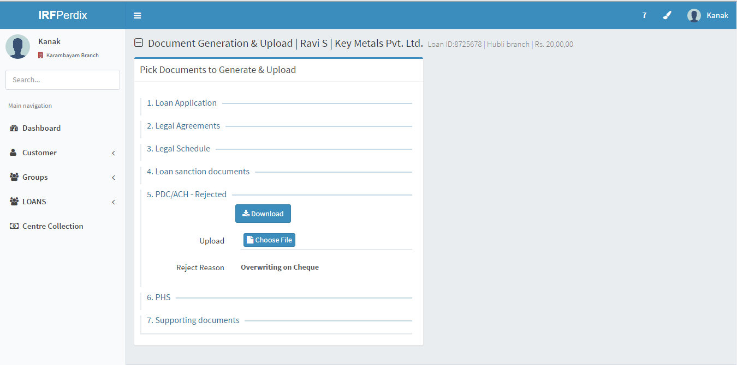

## Functional Requirements

Document Generation & Upload

1. This will list all the loans pending for document generation and upload.
2. Conditions: All loans passed from the previous stage, “Pending Loan Booking”.
3. All the loans will be displayed with basic details like
   * 1. Loan ID
     2. Entity Name
     3. Branch Name
     4. Disbursement date
     5. Loan Officer Name
     6. Spoke Name
     7. Hub Name
4. Search Option to be provided with Customer Name, Entity Name, and Branch Name.
5. Sorting can be done based on the above 7 fields.
6. Once we click on the loan account the list of documents to be generated and uploaded will get listed based on the product level parameters.
7. Upload validations listed below
   1. File format specific restrictions like loan application will be in PDF and Photo will be in JPEG
   2. Size of the file should be less than 1MB
8. View File– to view the uploaded documents. This button will be shown after the file is uploaded.
9. Click on submit should move the task to Document Verification stage.

## Upload

a. Document list shared in the Artifacts will be upload.

## Download

a. Document formats shared by Kinara for Download.

## Reports

-NA-

# 

# Pending for Document Verification

## UI requirements

|  |  |  |  |  |  |
| --- | --- | --- | --- | --- | --- |
| Field name | Section | Data Type | Attribute | Validations/Restrictions | Population logic |
| Approve/Reject | Verification details | Radio button | Write | Only one can be selected |  |
| Rejection reasons | Verification details | Drop down- text | Write | Only one can be selected | Based on the master –rejected reasons   |  | | --- | | Customer signature missing | | Schedule not uploaded as part of customer shared documents | | Others | |
| Rejection remarks | Verification details | Text | Write | Upto 200 characters. For all rejection reasons drop down, free text will be present to add remarks. |  |

## UI view- checker for document verification

|  |  |  |  |  |  |
| --- | --- | --- | --- | --- | --- |
| A**rtifact name(TBD)** |  | **Approve** | **Reject** | **Rejection reasons** | **Rejection remarks** |
| Loan Application | View |  |  |  |  |
| Legal Agreements | View |  |  |  |  |
| Legal Schedule | View |  |  |  |  |
| Customer shared documents | View |  |  |  |  |
| PDC/ACH | View |  |  |  |  |
| PHS | View |  |  |  |  |
| Supporting documents | View |  |  |  |  |

## Screenshots

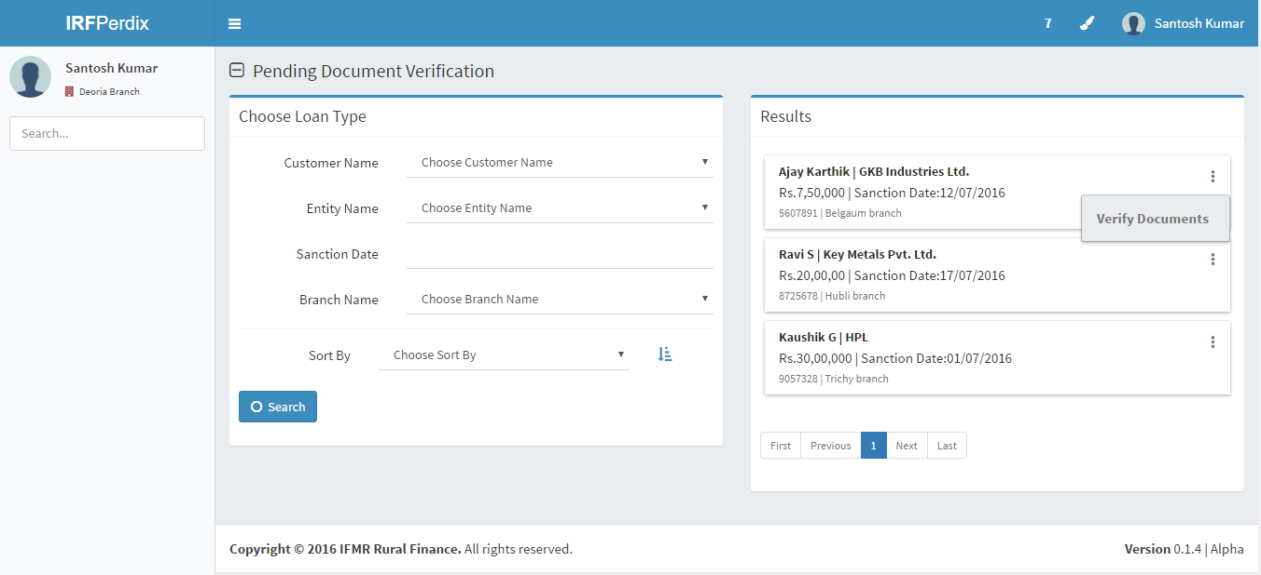

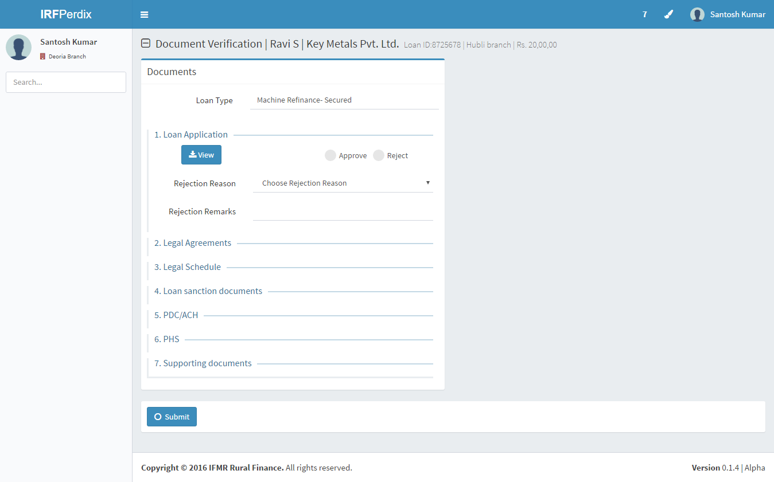

## Functional requirements

Document Verification Queue

* 1. This will list all the loan accounts for which documents are uploaded and pending for verification
  2. All the loans will be displayed with basic details like
     1. Loan ID
     2. Entity Name
     3. Branch Name
     4. Document Uploaded date
     5. Loan Officer Name
     6. Spoke Name
     7. Hub Name
  3. Search Option to be provided with Customer Name, Entity Name, and Branch Name.
  4. Sorting can be done based on the above 7 fields.

Document Verification for a Loan

1. select a loan account and action by selecting Document verification
2. In a new screen, all the documents that are attached to the Loan and listed document type wise.
3. User can click on the document type to download the file.
4. User will have an option to decide on approve/reject at the file level
5. Upon submit, the task will move to “Pending for Disbursement” queue provided all the documents are approved. Even if one of the document is rejected, the task will move to “Document Generate and Upload” for Hub Manager to correct the required file and re-submit.

## Uploads

-NA-

## Downloads

All Documents uploaded in Document Generate and Upload stage

## Reports

-NA-

# Ready for Disbursement

## UI Requirements

|  |  |  |  |  |  |
| --- | --- | --- | --- | --- | --- |
| **Field name** | **Section** | **Data Type** | **Attribute** | **Validations/Restrictions** | **Population logic** |
| Bank Name | Disbursement details | Text | Write | Drop down | Master data |
| Branch Name | Disbursement details | Text | Read | Auto | Based on Bank name selected- auto display |
| Account number | Disbursement details | Numeric | Read | Auto | Based on Bank name selected- auto display |
| Status | Disbursement details | Text | Write | Drop down | Master –  a.Sent to bank  b.Rejected – Only if tis rejected next 2 fields will be displayed. |
| Rejected reasons | Disbursement details | Text | Write | Drop down | Master data  1.Wrong IFSC code  2.Wrong account number  3. Wrong account name |
| Rejected Remarks | Disbursement details | Text | Write | Upto 30 characters |  |

## Screenshots

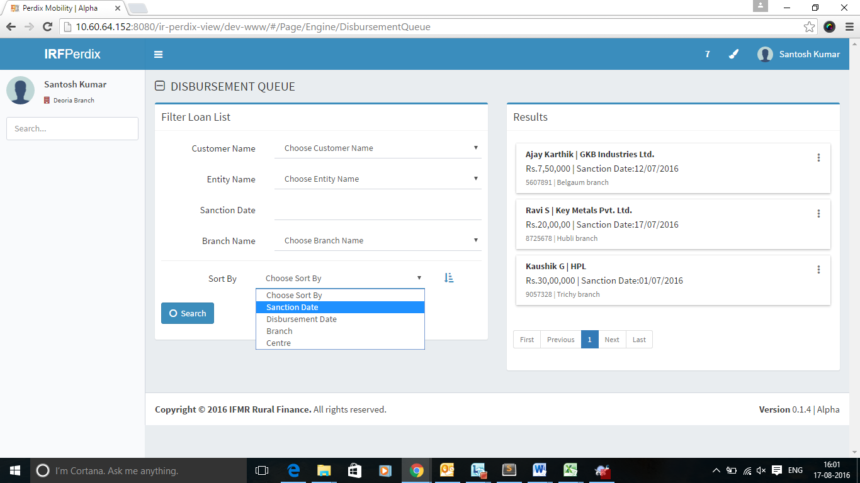

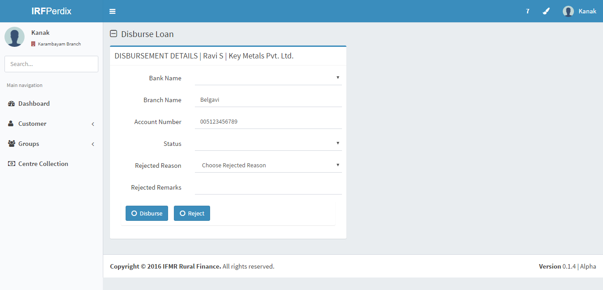

## Functional requirements

Pending for Disbursement Queue

1. This will list all the loans which for documents are verified and approved.
2. All the loans will be displayed with basic details like
   * + 1. Loan ID
       2. Entity Name
       3. Branch Name
       4. Document Verified date
       5. Disbursement date (captured in Loan booking stage)
       6. Loan Officer Name
       7. Spoke Name
       8. Hub Name
3. Search Option to be provided with Customer Name, Entity Name, and Branch Name.
4. Sorting can be done based on the above 7 fields.

Disbursement Details for a Loan

* 1. Click on the action “Disburse” for a Loan will take to a new screen where disbursement related details Kinara like Bank name, Branch Name, Account number which will be used to debit the disbursement amount will be captured.
  2. User can disburse or reject the Loan Disbursement. Rejecting the disbursement will route the task to “Rejected Disbursement Queue”. On disbursing the Loan, the task will move into “Disbursement Confirmation” Queue.

## Upload

* Upload excel after updating Kinara’s Bank account details for the disbursements in the downloaded excel.

## Download

* Download multiple Disbursements into an Excel.

## Reports

-NA-

# Rejected Disbursement

## UI requirements

|  |  |  |  |  |  |
| --- | --- | --- | --- | --- | --- |
| **Field name** | **Section** | **Data Type** | **Attribute** | **Validations/Restrictions** | **Population logic** |
| Finance Team Rejection remarks | Disbursement details | Text | Read |  | Data from the rejected disbursement in previous queue will be shown. |
| Finance Team Rejection reasons | Disbursement details | Drop Down | Read |  |  |
| Finance team rejected date | Disbursement details | Date | Read |  | Date on which the status is changed in the previous queue |
| Applicant IFSC Code | Disbursement details | Alphanumeric | Write | Validation for IFSC code to be done |  |
| Applicant Account name | Disbursement details | Text | Write | Upto 200 characters |  |
| Applicant bank account number | Disbursement details | Numeric | Write |  |  |
| Remarks- Hub Manager | Disbursement details | Text | Write | Upto 200 characters |  |

## Screenshots

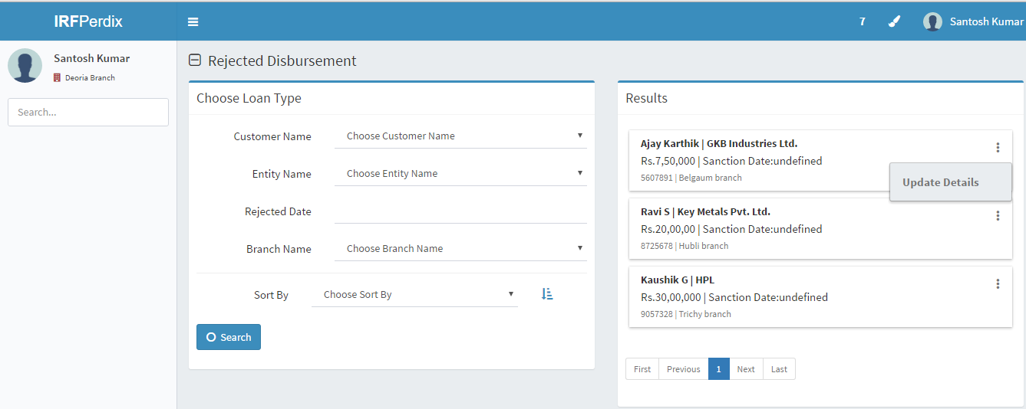

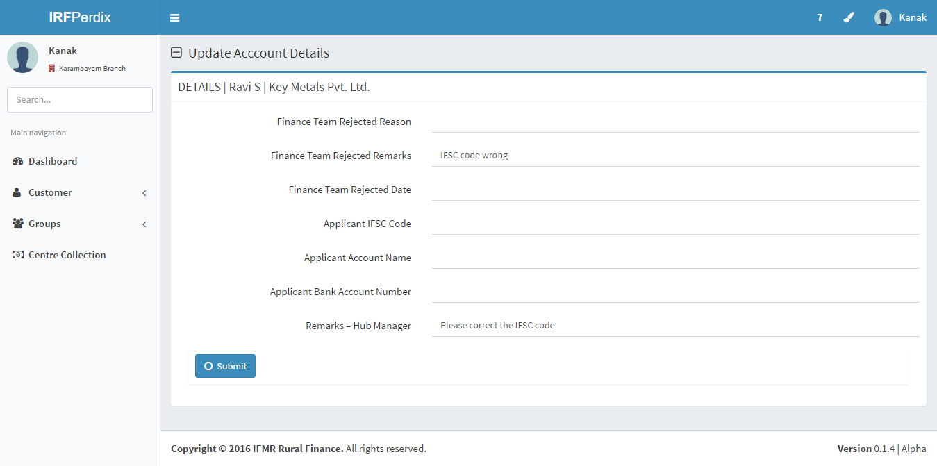

## Functional requirements

Rejected Disbursement Queue

1. This will list all the Loans disbursements which are rejected by the Finance team.
2. Filter/Sort will be based below details:
   1. Loan ID
   2. Entity Name
   3. Branch Name
   4. Rejected reasons
   5. Loan Officer Name
   6. Spoke Name
3. Search Option to be provided with Customer Name, Entity Name, and Branch Name.
4. Sorting can be done based on the above 7 fields.
5. Select the loan account, check the rejected reasons and provide the details.

Update Disbursement Details

* + 1. User clicks on the Loan and selects the action to “capture Details”.
    2. Hub Manager can update the correct IFSC Code, customer account number and customer name which will be accepted by the beneficiary bank.
    3. Click on Submit, will move this task to “Pending for Disbursement Queue”.

## Uploads

-NA-

## Downloads

-NA-

## Reports

-NA-

# Disbursement confirmation

## UI requirements

|  |  |  |  |  |  |
| --- | --- | --- | --- | --- | --- |
| **Field name** | **Section** | **Data Type** | **Attribute** | **Validations/Restrictions** | **Population logic** |
| Confirmation status | Disbursement details | Text | Write | Drop down - Based on check with bank statement. | Master  1. Confirmed  2.Rejected |
| Disbursement date | Disbursement details | Date | Write | Any date – as per bank statement |  |
| Finance Team Rejection remarks | Disbursement details | Text | Read |  | Data from the rejected disbursement in previous queue will be shown. |
| Finance Team Rejection reasons | Disbursement details | Drop Down | Read |  |  |
| Finance team rejected date | Disbursement details | Date | Read |  | Date on which the status is changed in the previous queue |

## Screenshots

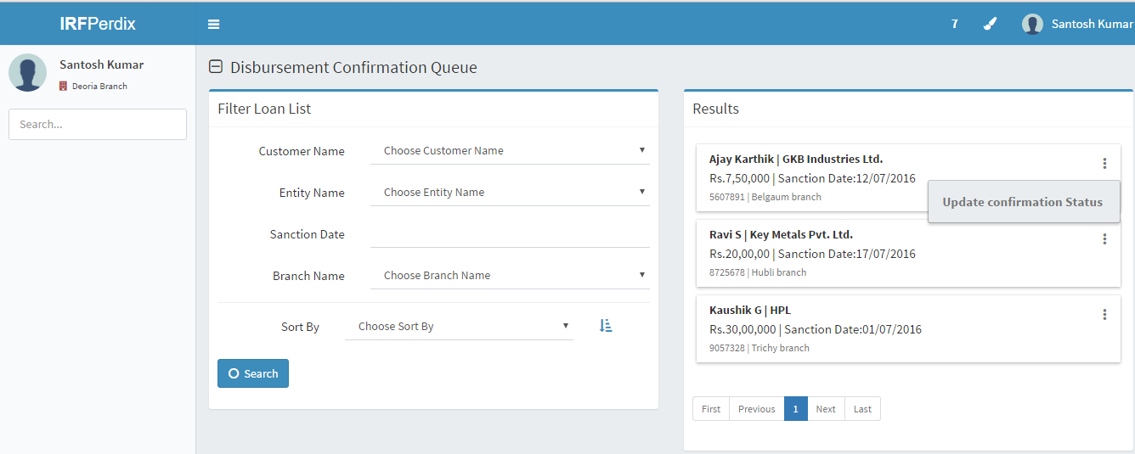

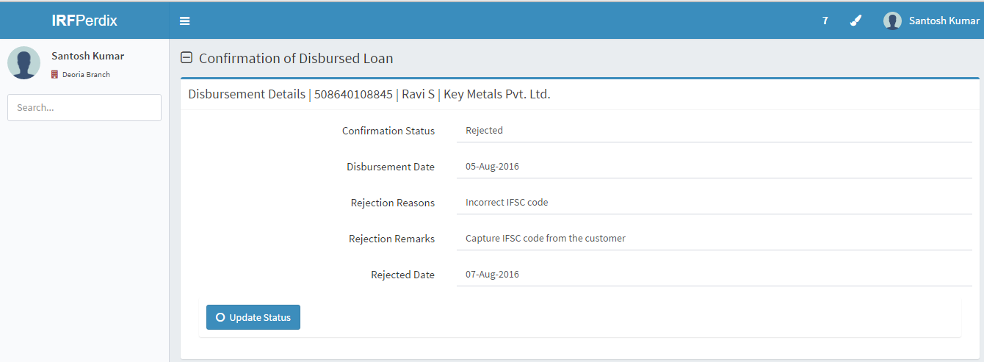

## Functional requirements

Disbursement Confirmation Queue

1. This will list all the disbursed accounts loans i.e. Accounts with status as sent to bank.
2. Filter/Sort will be based below details:
3. Loan ID
4. Entity Name
5. Branch Name
6. Rejected reasons
7. Loan Officer Name
8. Spoke Name
9. Search Option to be provided with Customer Name, Entity Name, and Branch Name.
10. Sorting can be done based on the above 7 fields.
11. User may choose to update the loan account individually or utilize upload via excel feature to update the status for a bulk for transaction.

Disbursement Confirmation

1. Upon clicking the individual loan account, a new screen will be shown in which disbursement confirmation status and rejected reason and remarks will be captured by the Finance team.
2. On save, if the status is “Rejected”, it will move into “Rejected Disbursement Queue”.

## Uploads

-NA-

## Downloads

-NA-

## Reports

Report on disbursement status of loan.

# Multiple Tranche Process

## UI requirements

|  |  |  |  |  |  |
| --- | --- | --- | --- | --- | --- |
| **Field name** | **Section** | **Data Type** | **Attribute** | **Validations/Restrictions** | **Population logic** |
| Tranche details | Sanction details | Text | Read |  | Sample as below:  1st tranche – 50%  2nd tranche – 30%  3rd tranche – 20%  Remarks will be mentioned at the time of sanction example – second tranche to be disbursed only after machinery is purchased. |
| Disbursement Date | Sanction details | Date | Write |  | Capture the disbursement date for the disbursement of the selected Tranche |
| Customer sign Date | Sanction details | Date | Write |  | Capture customer sign date as signed by the customer in the EMI schedule generated for this tranche |
| Remarks for tranche disbursement | Multiple tranche details | Text | Write |  | Remarks will be entered by Hub Manager. |
| Sent to FRO Verification | Multiple tranche details | Button | Click |  |  |

## Screenshots

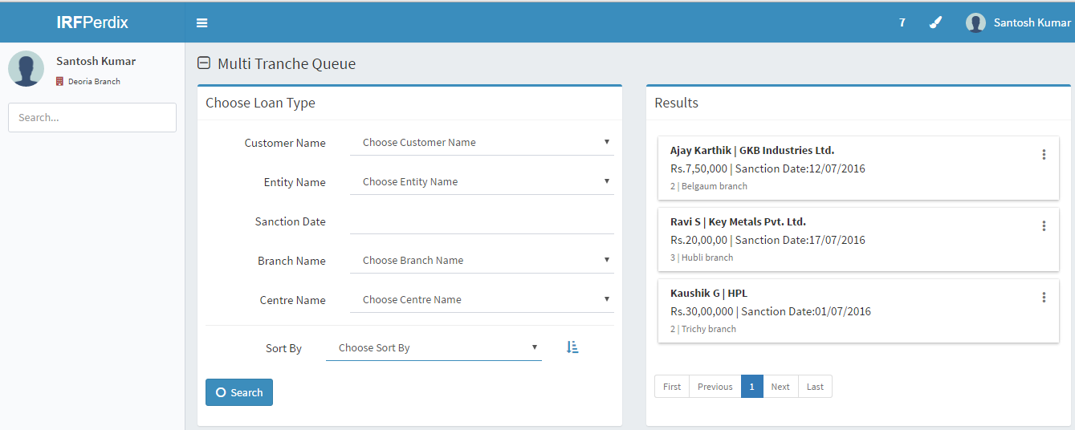

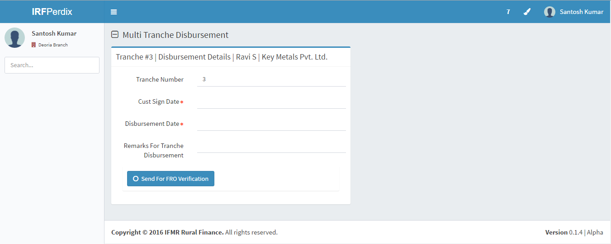

## Functional Requirements

1. At the time of sanction, these tranche details are captured and displayed in the Hub Manager login.
2. If it’s the 1st tranche, then the entire loan booking process mentioned in the above process from Pending for loan booking till disbursement will continue. It will show as 1st tranche as auto selected.
3. For the next tranche, customer will check with hub manager whether he can go for second tranche. Then Hub Manager will initiate the tranche disbursement process.
4. Hub Manager will enter remarks and click on Submit – this will move to FRO Verification Pending.

## Uploads

-NA-

## Downloads

-NA-

## Reports

-NA-

# Pending for FRO(Field Risk Officer) Approval

## UI Specification

|  |  |  |  |  |  |
| --- | --- | --- | --- | --- | --- |
| **Field name** | **Section** | **Data Type** | **Attribute** | **Validations/Restrictions** | **Population logic** |
| Tranche details | Sanction details | Text | Read |  | Sample as below:  1st tranche – 50%  2nd tranche – 30%  3rd tranche – 20%  Remarks will be mentioned at the time of sanction example – second tranche to be disbursed only after machinery is purchased. |
| Approve/Reject | FRO Verification details | Radio button | Write |  |  |
| Approve Remarks | FRO Verification details | Text | Write | Limit up to 200 characters |  |
| Rejection remarks | FRO Verification details | Text | Write | Limit up to 200 characters |  |
| Verification date | FRO Verification details | Date | Write | Today and greater than today |  |

## Screenshots

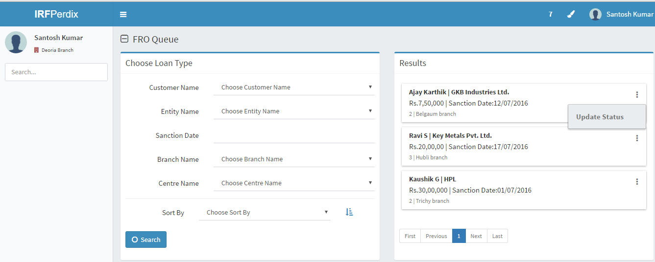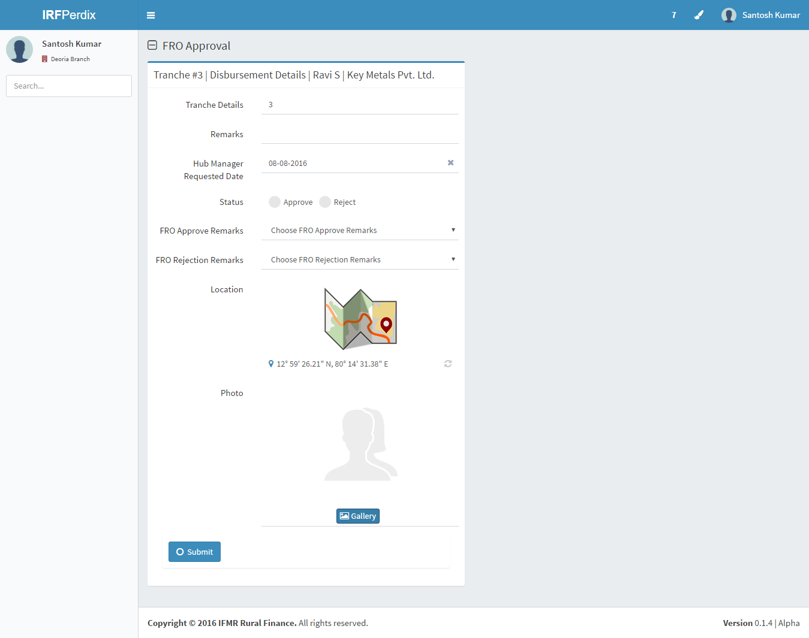

## Functional Requirements

1. Field Risk Officer logs in

i. All loans pending for second or greater than second tranche will display in the dashboard.

ii. Pending for tranche with the count will be displayed.

1. Filter and search should be based on the below details
   * 1. Loan ID
     2. Entity Name
     3. Branch name
     4. Loan Officer name
     5. Spoke name
     6. Hub Name
     7. Search Option to be provided with Customer Name, Entity Name, and Branch Name.
     8. Sorting can be done based on the above 7 fields.
2. Field Risk Officer will check the customer eligibility for the second tranche and approve.
3. On approval, it will go to Pending for CRO Approval.
4. On Rejection, it will go back with rejection reasons for multi tranche stage to Hub Manager.

## Uploads

-NA-

## Downloads

-NA-

## Reports

-NA-

# Pending for CRO (Central Risk Officer) Approval

## UI Requirements

|  |  |  |  |  |  |
| --- | --- | --- | --- | --- | --- |
| **Field name** | **Section** | **Data Type** | **Attribute** | **Validations/Restrictions** | **Population logic** |
| Tranche details | Sanction details | Text | Read |  | Sample as below:  1st tranche – 50%  2nd tranche – 30%  3rd tranche – 20%  Remarks will be mentioned at the time of sanction example – second tranche to be disbursed only after machinery is purchased. |
| Remarks | FRO Verification details | Text | Read |  |  |
| Verification date | FRO Verification details | Date | Read | Today and greater than today | Based on previous queue |
| Approve/Reject | CRO Verification details | Radio button | Write |  |  |
| Approve Remarks | CRO Verification details | Text | Write | Limit up to 200 characters |  |
| Rejection remarks | CRO Verification details | Text | Write | Limit up to 200 characters |  |

## Screenshots

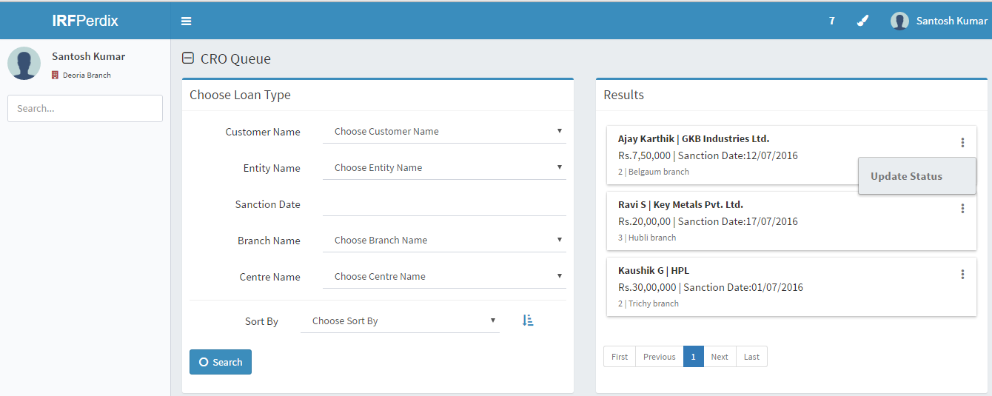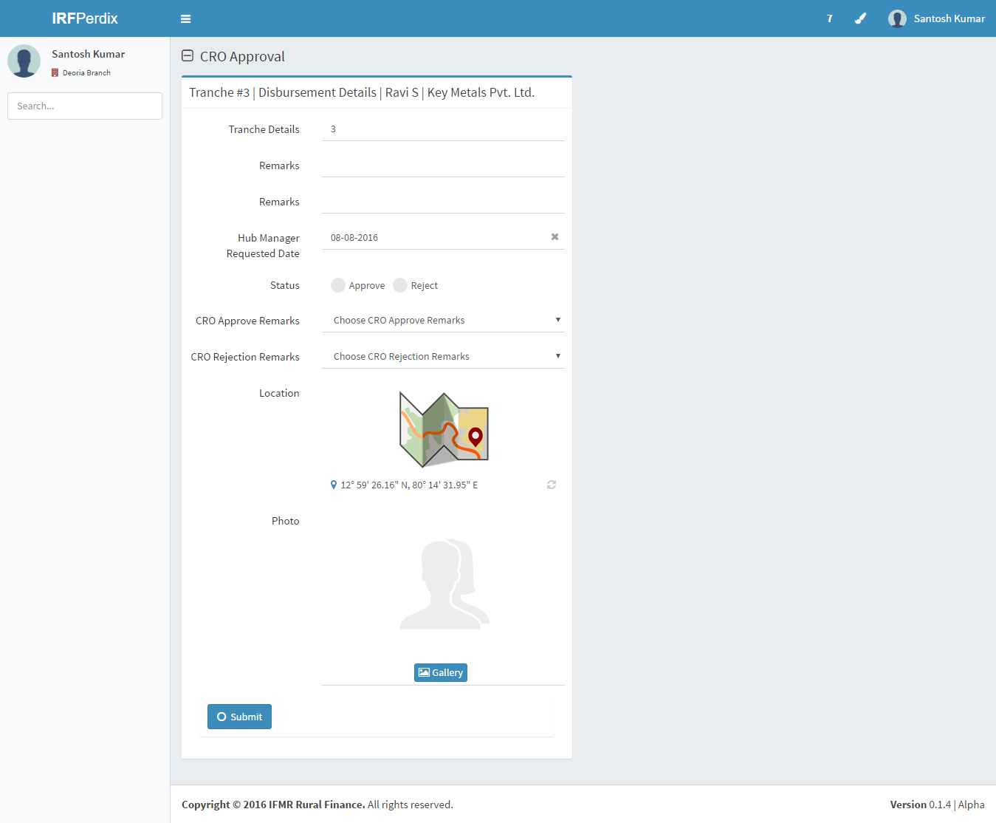

## Functional requirements

1. Credit Risk Officer logs in

i. All loans approved by Field risk Officer for second tranche disbursement will be displayed in the dashboard.

ii. Pending for CRO approval with the count will be displayed.

1. Filter and search should be based on the below details
   1. Loan ID
   2. Entity Name
   3. Branch name
   4. Loan Officer name
   5. Spoke name
   6. Hub Name
   7. FRO Verified date.
   8. Search Option to be provided with Customer Name, Entity Name, and Branch Name.
   9. Sorting can be done based on the above 7 fields.
2. Central Risk Officer will check the customer eligibility for the second tranche and approve for disbursement.
3. On approval, it will go to Pending for Loan Booking at Hub Manager login.
4. On Rejection, it will go back with rejection reasons for multi tranche stage to Field Risk Officer.

## Uploads

-NA-

## Downloads

-NA-

## Reports

-NA-

# EMI Schedule Generation

## UI Requirements

|  |  |  |  |  |  |
| --- | --- | --- | --- | --- | --- |
| **Field name** | **Section** | **Data Type** | **Attribute** | **Validations/Restrictions** | **Population logic** |
| Tranche details | Sanction details | Text | Read |  | Sample as below:  1st tranche – 50%  2nd tranche – 30%  3rd tranche – 20%  Remarks will be mentioned at the time of sanction example – second tranche to be disbursed only after machinery is purchased. And the respective tranche will be auto selected. |
| Customer Sign Date | Booking details | Date | Write | a. Date >= today | Date format (DD/MM/YY) |
| Expected Disbursement Date | Booking details | Date | Read/Write | a.Date – Auto Populate (Customer sign date+ 2)  b.Provision to change to any future date – which is greater than (customer sign date+2) | Date format (DD/MM/YY) |
| FRO Approval Remarks | Sanction details | Text | Read |  | Approval Remarks provided by FRO |
| CRO Approval Remarks | Sanction details | Text | Read |  | Approval remarks provided by CRO |

## Screenshots

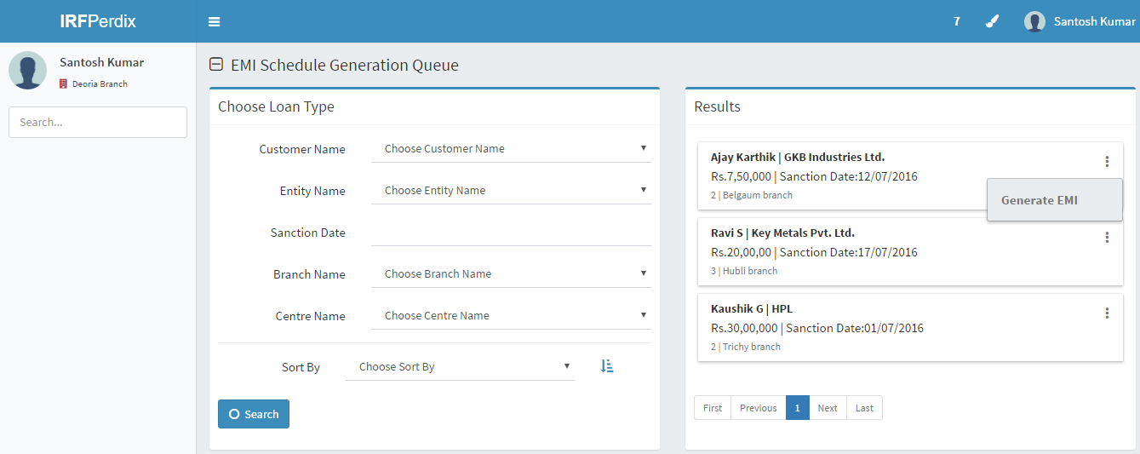

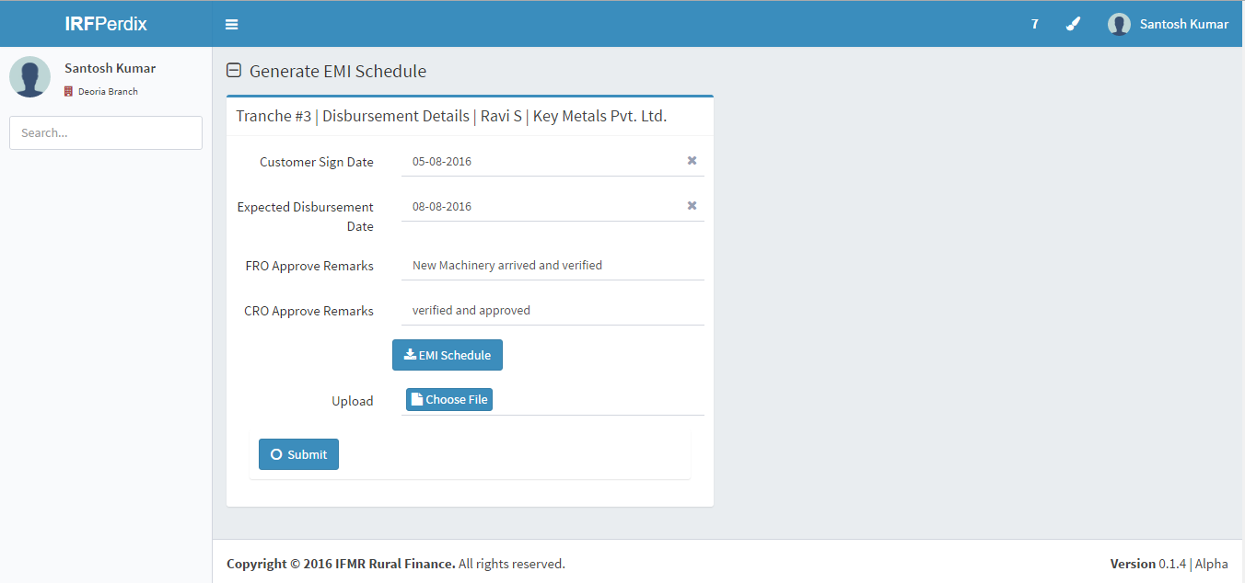

## Functional Requirements

1. Hub Manager Dash board:
2. Dash board will show all the loans pending for loan booking.
3. Conditions: All loans which have been sanctioned and not booked count will be displayed in this screen.
4. Pending for Loan Booking:
5. Once you click on Pending for Loan booking.
6. All the loans will be displayed with basic details like
   * 1. Loan ID
     2. Entity Name
     3. Branch Name
     4. Sanction Date
     5. Loan Officer Name
     6. Spoke Name
     7. Hub Name
7. Search Option to be provided with Customer Name, Entity Name, and Branch Name.
8. Sorting can be done based on the above 7 fields.
9. On entering the customer sign date and expected disbursement date, click on submit.
10. New EMI Schedule with the current loan amount for second tranche will be generated with the disbursement date on it.
11. Hub Manager will obtain customer signature and upload the document for verification.

*Note: From here the loan booking process will follow from the Pending for Document Verification (to be done by MIS team HO).*

## Uploads

-NA-

## Downloads

-NA-

## Reports

-NA-